******The British College**

**KATHMANDU**

**Name: Devansh Agarwal**

**University ID: c7202298**

**Advanced Web Engineering**

In the above picture you can see that XDebug is install in the IDE I prefer using which is Sublime Text. The process was installing xdebugging tool from preferences. **A screenshot of a computer screen
**

In the above picture you can see that Sublime text the IDE of my choice is installed and is working properly.

XAMPP control panel is installed and is working. Apache server is active and the ports are working good as asked in the requirement.

Localhost server is fully functional after the apache server is turned in from XAMPP control Panel. As you can notice the XAMPP default dashboard is working and is accessible.

After Installing git to your PC, You can see we get multiple programs and feature which makes easier for us to use git. The above picture contains of the program Git GUI.

Not only Git GUI but you even get access to Git CMD and in the above picture you can see that it is in proper working condition.

Even Git bash is working fine as expected after the installation of git was done. All the files were added, clones, commit and pushed from git bash.

XDebug code edited in php.ini file inside xampp to do code debugging configuration successfully.

Above Images show that Task on was added, committed and pushed correctly and the file was uploaded as expected.

While pushing the file to git hub respiratory you need to give your ID and password for authentication and the process was completed successfully as seen in above image.

As seen in the image the Task 1 is completed successfully. And with 0 errors, all the requirements are fulfilled as asked by the University.

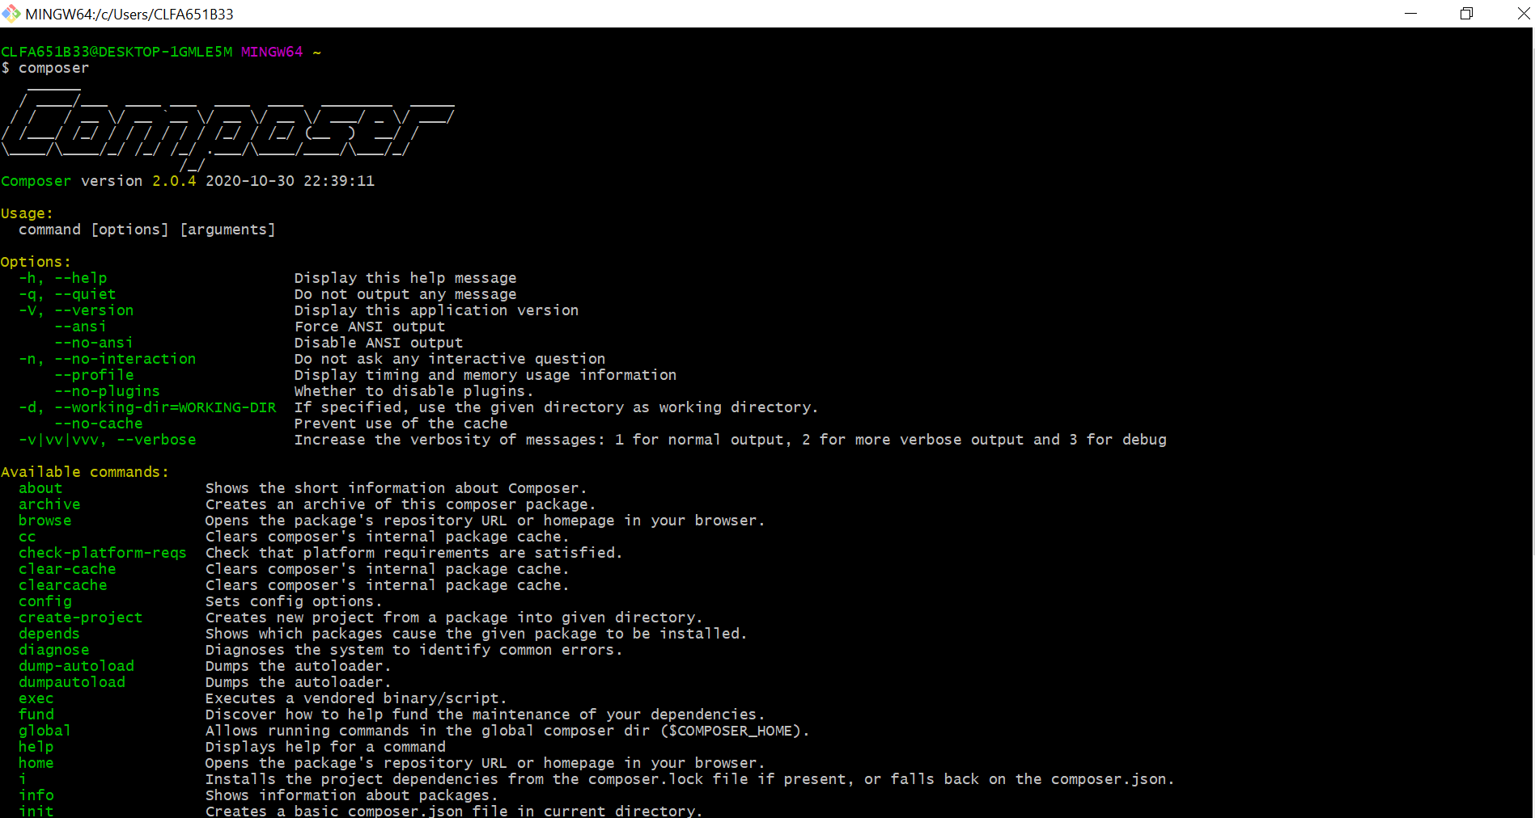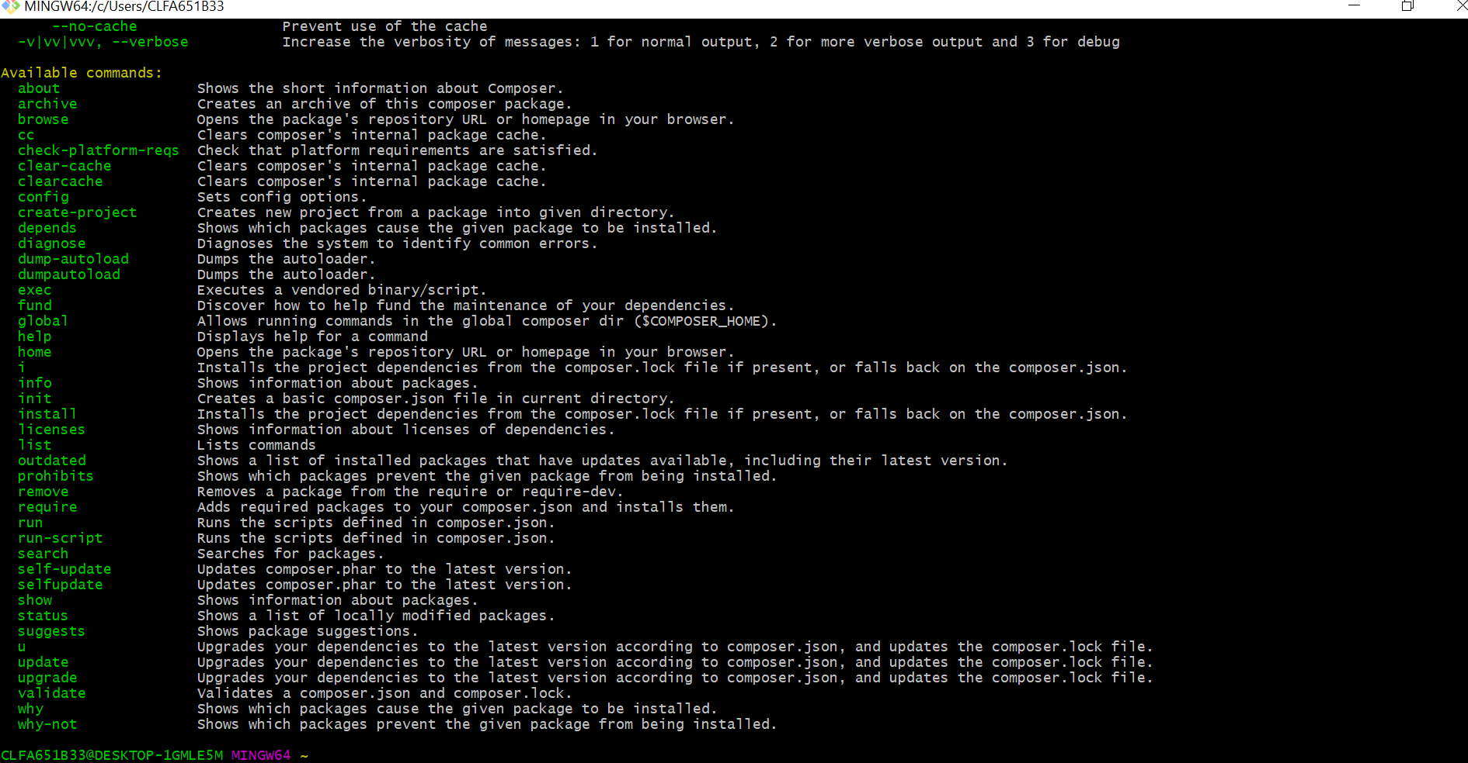

Above given are successful screenshots of that the installation is complete of composer in the pc.